**Exercise 2: Error Handling**

**Scenario 1: Handle exceptions during fund transfers between accounts.**

**Question: Write a stored procedure SafeTransferFunds that transfers funds between two accounts. Ensure that if any error occurs (e.g., insufficient funds), an appropriate error message is logged and the transaction is rolled back.**

**Step 1:**

The Existing Accounts Data

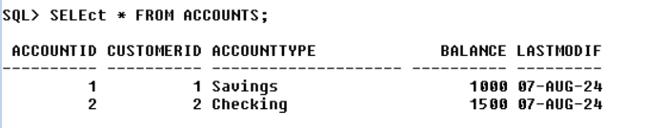

Step 2:

The Pl/SQL Code:

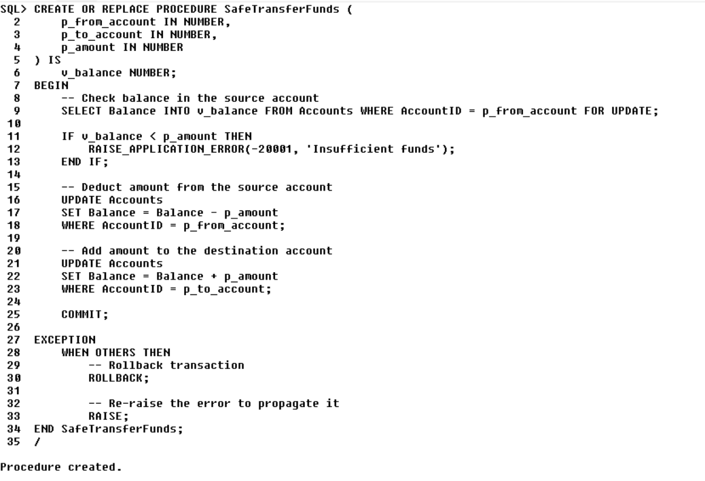

Step 3:  
After Execution  
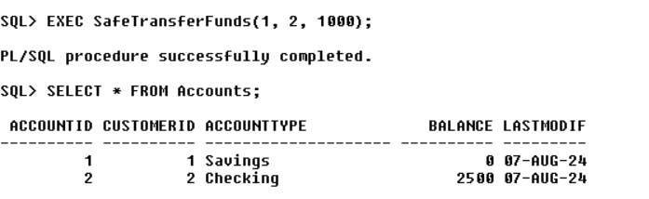

After Execution with errors

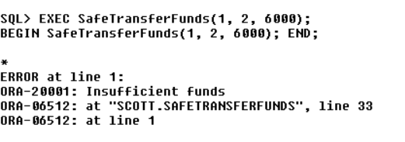

**Scenario 2: Manage errors when updating employee salaries.**

**Question: Write a stored procedure UpdateSalary that increases the salary of an employee by a given percentage. If the employee ID does not exist, handle the exception and log an error message.**

**Before Execution:**

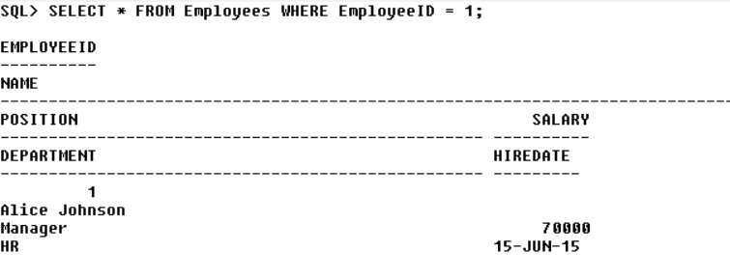

**The Pl/SQL Code Execution:**

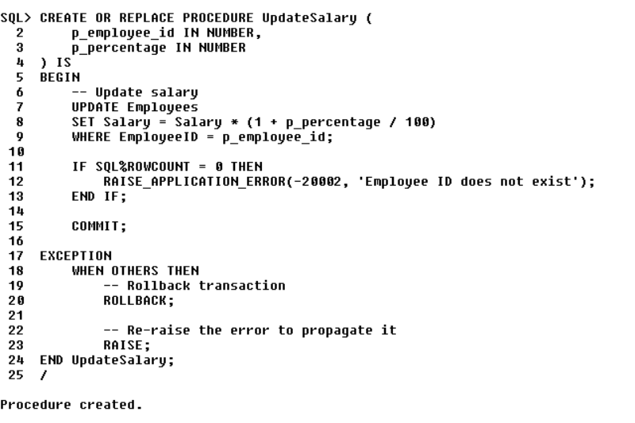

**After Execution of the code**

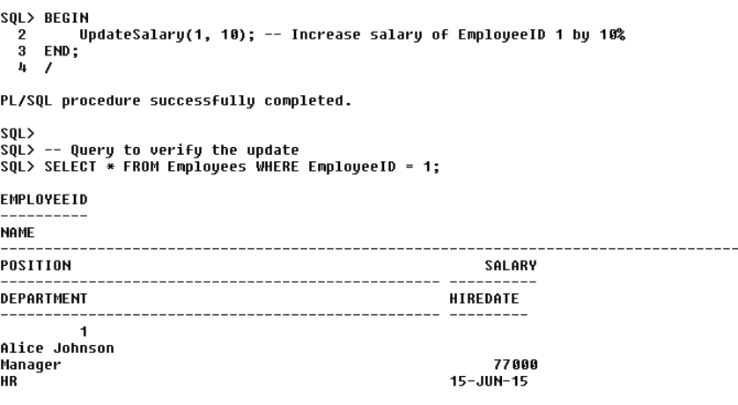

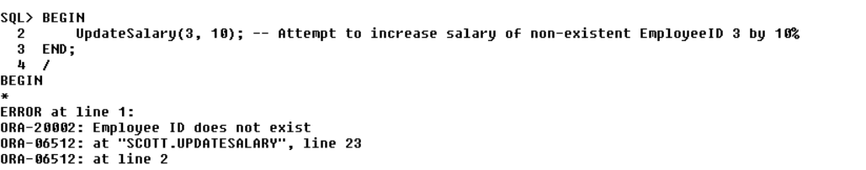

**Scenario 3: Ensure data integrity when adding a new customer.**

**Question: Write a stored procedure AddNewCustomer that inserts a new customer into the Customers table. If a customer with the same ID already exists, handle the exception by logging an error and preventing the insertion.**

**The PL/SQL CODE:**

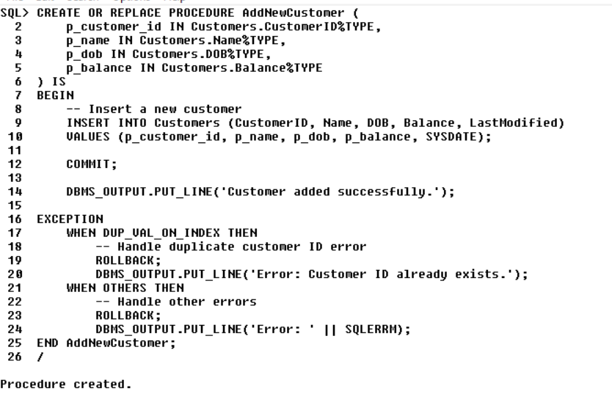

**After Execution:**

